Nothing But Net, an investment club made up of GARMIN employees, invests in companies that have a history and future potential of growing earnings at 15% or better per year. We believe that, in the long term, as a company grows its earnings, the price investors are willing to pay for owning a share of the company also grows. With this in mind, we meet on the third Wednesday of each month to discuss our portfolio. If you have an interest in stock investing or would like to learn more, feel free to attend this or one of our other club meetings. Visitors are always welcome.

How we do it - Part 1

The following graphs provide a 10 year historical look at two different companies. A quick glance tells us if sales are growing and if management is able to translate sales growth into a corresponding earnings growth. Past performance does not guarantee future performance but experience has shown that if we pick 5 quality growth companies, 4 will continue the upward trend. We use diversification to protect our overall portfolio return from the 1 that disappoints. Take a look at the graphs. Which company would you rather have in your portfolio?

Green Line = Sales
Blue Line = Earnings per Share
Black Bar = 1 Year Share Price Range

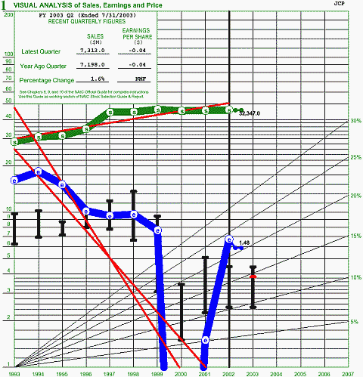

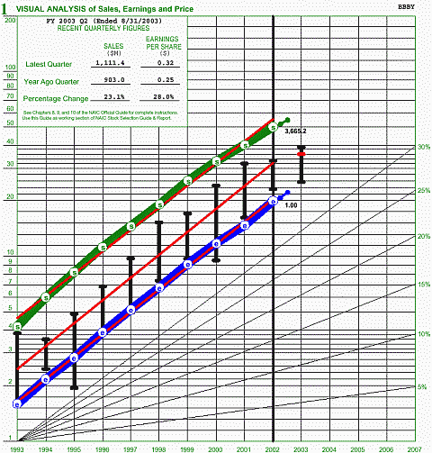

How we do it - Part 2

In part 1 we looked at how our club identifies quality growth companies. However, before we add shares to our portfolio we make sure the current price is fair and that our long term return goal can be achieved. We consider the current price to be fair if a historical price to earnings (PE) analysis shows the current PE to be close to the stocks average. We then conservatively estimate what we think the company will report for annual earnings 5 years into the future. Using this earnings estimate and high, low and average PE's from our analysis, we can estimate what investors will pay for a share of ownership in the future. If this results in a return that meets our 15% objective with little down side, we buy. The following example shows the results graphically.

To learn more, consider visiting Nothing But Net or City Stockers at one of our club meetings. If you like learning on your own, I highly recommend reading the book "Take Stock" by Ellis Traub.

Green Line = Sales
Blue Line = Earnings per Share
Black Bars = 1 Year Share Price Ranges
Red Line = Current Price ($58) and Future Projected Average Price ($150)

