Nothing But Net is an investment club whose membership is made up of GARMIN employees. We search for and invest in public companies that have a history and future potential of growing earnings at 15% or better per year. Our members believe that in the long term, as a company grows its earnings, the price investors are willing to pay for a share of ownership also grows. With this in mind, we meet on the third Wednesday of each month to manage our portfolio. If you have an interest in stock investing or would like to learn more, feel free to attend any of our club’s meetings. Visitors are always welcome.

When: 12:00 – 1:00 on the 3rd Wednesday of each month.
Where: Garmin Headquarters, Tower, Room 2-6110.

How We Do It

The following graphs provide a ten year historical look at two different companies. A quick glance tells us if sales are growing and if management is able to translate sales growth into a corresponding earnings growth. Past performance does not guarantee future performance but experience has shown that if we pick five growth companies of good quality, four will continue the upward trend. We use diversification to protect our portfolio from the one that disappoints. Take a look at the graphs. Which company would you rather have in your portfolio?

Green Line = Sales
Pink Line = Profits
Blue Line = Earnings per Share
Black Vertical Bars = One Year Share Price Ranges

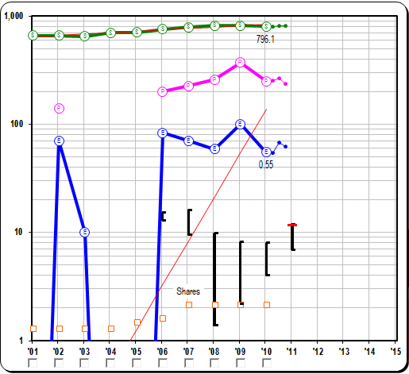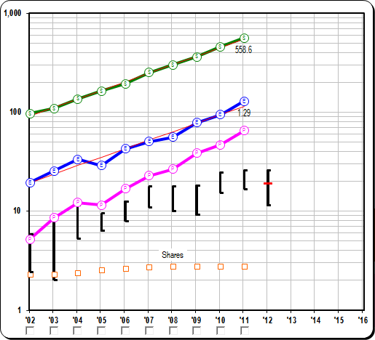

How We Do It - Continued

Before we add shares of good quality growth companies to our portfolio we make sure the current price is fair and that our long term return goal can be achieved. We consider the current price to be fair if a historical price to earnings (PE) analysis shows the current PE to be close to the stock’s average. We then conservatively estimate what we think the company will report for annual earnings five years into the future. Using this earnings estimate and historical PE’s, we can estimate what future investors might pay for a share of ownership. If this results in a return that meets our 15% objective with little downside risk, we buy. The following example shows the results graphically.

Green Line = Sales
Pink Line = Profits
Blue Line = Earnings per Share
Black Vertical Bars = One Year Share Price Ranges
Red Horizontal Bars = Current Price ($19) and Estimated Future Price ($52)

